Hardware Governance Requirement

**Security Requirements: -**

There are three groups in Group Gennie who will access this dashboard of Hardware Governance, the details of the groups are given in below table.

The access is given by site name and assignment group. The user is assigned to an assignment group, that group is mapped to a site location. Now if the user belongs to groups given in the table, belongs to an assignment group and the respective site, should be able to access all the assignment groups of that site. What this means that a site can have multiple assignment groups and vice-e-versa. Hence the relationship will come from assignment group table to the member of the group gennie. This security is at site level and should be used at dashboard level access.

The 2nd level of access should be at report level where we need to create a filter where for a specific site you should be able to see linked assignment group, and user has option to select those groups via filter option.

The relationship between 3 components will be based on below diagram: -

Site 1

Assignment Group 1 Site 2

Group Genie Group Assignment Group 2 Site 3

Assignment Group 3 Site 4

So the number of records should be multiplied with the relationship values between 3 components of security for security filter tables.

**Note: -** All the group genie users should be able to see all the unregistered hardware devices as the assignment group is not assigned to unregistered devices.

**Note: -** Apps impact items: - We need to create a flag which states called “Is Member”. For this filter, if the value is YES, then user can see only the hardware of the assignment groups which the user is the Member. If this flag is NO, he can see the hardware of all assignment groups belonging to the site which is owner is mapped via assignment group.

|  |  |  |  |
| --- | --- | --- | --- |
| **Persona** | **Group Genie Group** | **Asset Categories** | **Access to Assignment Group and Respective Site** |
| **Global Stakeholder** | GDSG-RITA-Asset Admin | Application and Hardware | Assignment Group belonged and whole Site of associated assignment group |
| **Integrator** | GDSG-RITA-Integrator | Hardware | Assignment Group only |
| **Site Security Leader** | GDSG-RITA-SSL | Hardware | Assignment Group belonged and whole Site of associated assignment group |

For Dashboards and Folder Structure, Under the Hardware Folder, we will have 3 dashboards, 1 for each group genie owner. So the idea is the data level security will be at individual dashboard for an individual group, so there will be a dashboard level security as well which is by group. The details of groups and respective dashboard name is: -

|  |  |  |
| --- | --- | --- |
| **Persona** | **Group Genie Group** | **Dashboard Name** |
| **Global Stakeholder** | GDSG-RITA-Asset Admin | Hardware Governance for IT Asset Admin |
| **Integrator** | GDSG-RITA-Integrator | Hardware Governance for Integrator |
| **Site Security Leader** | GDSG-RITA-SSL | Hardware Governance for Site Security Leader |

**Derived Report Level Filters: -**

These filter will be applied at page level of pages of dashboard. Some of the filters will require creation of attributes and details are specified in below table.

|  |  |  |
| --- | --- | --- |
| **Filter Name (LoV Attributes)** | **Value of the Attribute** | **Attribute Required** |
| Is Registered is 1 | used to filter for devices which are already registered in SNOW (exlcuding those which are only scanned and found in Tenable) | Yes (Values as Yes/No) |
| Lifecycle Status is not duplicate_invalid or decommissioned | used to filter for active devices only | No |
| Hardware Status is not duplicate_invalid or decommissioned | used to filter for active devices only | No |
| Assignment Group is not (Blank) | used to filter only for devices which are assigned to an Assignment Group | No |
| Is ITAM Assignment Group | used to filter only for devices which are assigned to an Assignment Group with "ITAM" in its name | Yes (Values as Yes/No) |

**Metrics of Application Governance: -**

IT Asset Management KPIs

1. # Registered Devices

- This is the total count of registered devices in ServiceNow mapped to your assignment group. Clicking on this tile will show you a list of all registered devices in your assignment group.

2. # Active Devices

- This is the total count of registered devices in your assignment group whose hardware status is “installed”. “Installed” status means that the device is currently in use. Clicking on this tile will show you a list of all active devices in your assignment group (site).

3. % Lifecycle Status Availability

- This is the % of registered devices in your assignment group whose hardware status is not blank or NULL. This is a mandatory field in Device Registration and needs to be populated. Clicking on this tile will show you a list of all registered devices in your assignment group (site) whose lifecycle status in blank or NULL.

4. % Lifecycle Status Accuracy

- This is the % of registered devices in your assignment group whose hardware status is correct. A lifecycle status is deemed incorrect if one of the following scenarios occur:

Hardware Status = installed and Last Seen date > 60 days. If your device is active, it should be seen within the last 60 days.

Hardware Status = Decommissioned, Defective, In Stock, Missing, or On Order and Last Seen date <= 60 days. If your device is not yet active, it should not be seen in the network in the last 60 days.

Hardware Status = Blank. There should be no blank Lifecycle Status for all devices.

Clicking on this tile will show you a list of all registered devices in your assignment group (site) whose hardware status is incorrect.

This metric excludes all non-network connected devices.

5. % Site Accuracy

- This is the total count of registered devices in your assignment group with correct site information. A Site is deemed incorrect if the following scenario occurs:

Site Code = blank or Site Name = blank. There should be no blank Site Codes or Site Names for all devices.

Site Active = False. Only Active Sites should be used.

Site Type is one of 'country', 'area', 'region', 'group', 'sub group'. Site aggregates such as Country or Region should not be used.

6. % Ownership Accuracy

- This is the % of registered devices with Active P&G employees as owners in your assignment group. Clicking on this tile will show you a list of all registered devices with non-P&G or inactive P&G employees as owners in your assignment group (site).

7. # Unregistered Devices

- The count of Unregistered Devices is taken from Tenable discovery data. Only devices with DNS or NetBIOS names are considered as valid Unregistered Devices. The IP addresses of these devices are mapped with the BT IP Diamond report to determine the sites where they belong. The denominator for Registered Devices is the sum of Registered Devices in Service Now and the count of valid Unregistered Devices in Tenable. As Site Security Leader, you are expected to investigate on the Unregistered devices in your site and register them if they are valid company assets.

Site Security Leaders should see registered devices which have an assignment group assigned and also unregistered devices captured by the scanning solution in the respective sites. You should not see registered "orphan" devices. Also "HP ILO" device types (peripherals added on to DXC servers to allow remote access/control​) should be excluded.

8. % Registered Devices

- The numerator is Registered Devices and the denominator is the sum of Registered Devices in Service Now and the count of valid Unregistered Devices in Tenable.

9. % Unregistered Devices

- The numerator is Unregistered Devices and the denominator is the sum of Registered Devices in Service Now and the count of valid Unregistered Devices in Tenable.

10. # Unregistered Devices on Disposable Watchlist

- Count of unregistered devices where “Last Seen” > 90 days.

11. # Managed Devices (# Non-EVP Enrolled Windows Devices)

- Devices falling into the following classes which cannot be found in the following Discovery Sources:

Classes:

- Windows Server

- Computer

- Laptop PC

- Desktop PC

- Smartphone

- Tablet

Discovery Source:

- AUCMDB

- Interstates

- MARIMBA

- Airwatch

12. % Managed

- The numerator is “# Managed Devices” and the denominator is the sum of Registered Devices in Service Now and the count of valid Unregistered Devices in Tenable.

13. # Obsolete OS Offline Devices

- This is the total count of registered offline devices in your assignment group (site) in Service Now having Obsolete OS. An offline device has its On Network attribute = NO. The following Windows OS versions are also considered Obsolete: 2000, 2003, NT, Vista, XP, Win7, Windows7 - Clicking on this tile will show you a list of all registered offline devices in your assignment group (site) in Service Now having Obsolete OS. - As Site Security Leader, you are expected to drive OS upgrade to these offline devices in your site.

The logic checks Operating System and Operating System version (if available) attributes vs. valid entries in the Operating System catalogue

**Dashboard**

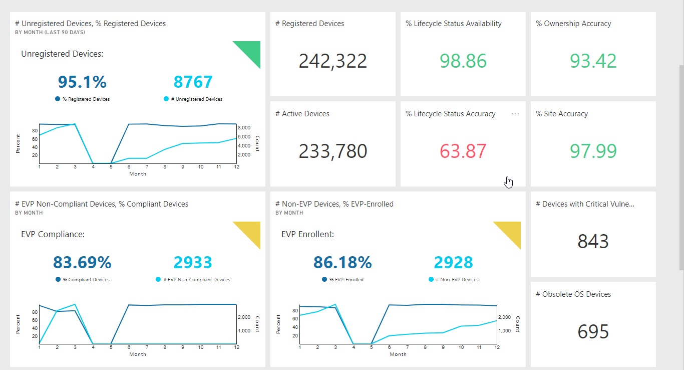

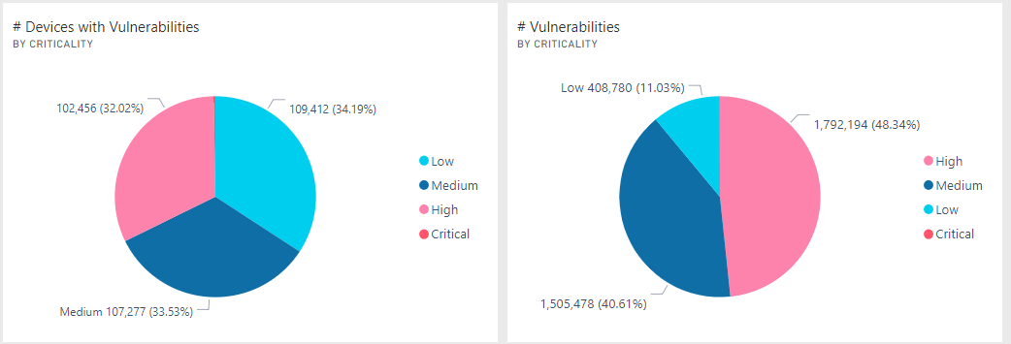

**Note: -** For this we might need to create a Dynamic Dashboard with the details like above. Will create mockup and review the non-possibility of creating a DD and try to achive this with VI only. But a headsup.

**Overall View Page (For IT Asset Admin)**

1. List of Attributes as Report

Assignment Group

Site Name, Region, Area, Country

1. List of Attributes and metrics in Report

Assignment Group

Site Name

Security Lead

Total Active Devices

%Site Accuracy

%Life Cycle Status Accuracy

# Unregistered Devices

# Registered Devices

# Active Devices

1. List of Metrics Used: - Metrics Section  
   Total Active Device  
   %Site Accuracy   
   %Ownership  
   %Life Cycle Status Accuracy

% Unregistered Devices

1. Page Level Filter

Is Registered as Yes

Is Member as Yes

Life Cycle Status is not in (Decommissioned, Duplicate_invalid)

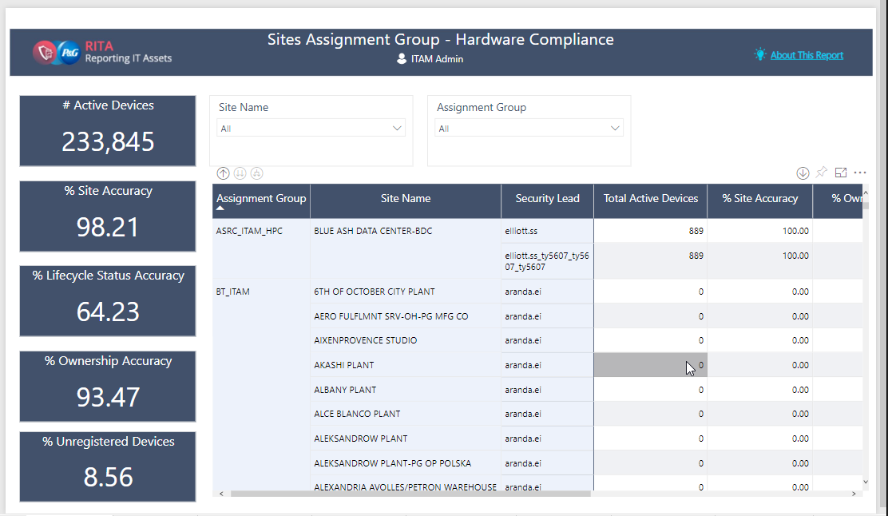

**Global View (for Site Security Leader)**

1. List of Attributes Used

Assignment Group

1. List of Metrics Used

Unregistered Devices

Registered Devices

Total Active Devices

% Registered Devices

% Managed

% Ownership Accuracy

1. Report Level Filter

Life Cycle Status is Installed

1. Page Level Filter

Site Name and Assignment Group

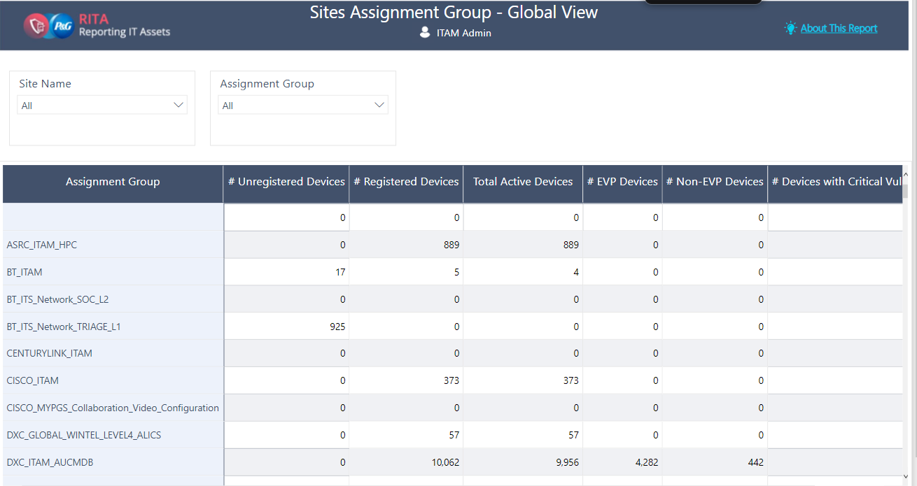

**Registered Device (For All Groups)**

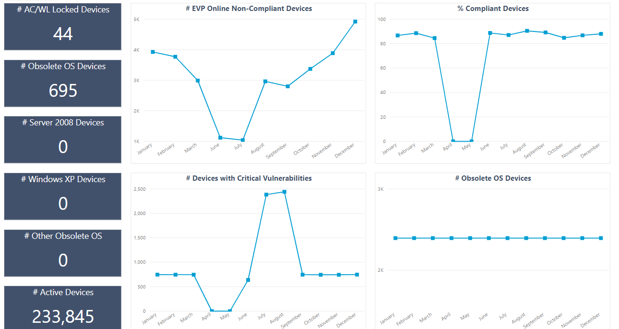

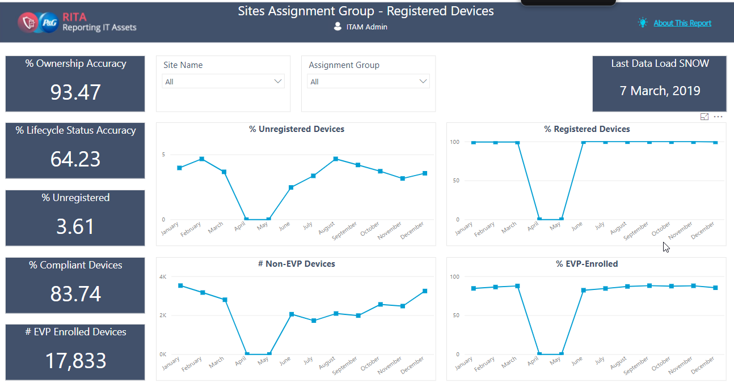

**Device Details (For All Groups)**

1. List of Attributes Used

Device Name

Site Name

Site Code

Device Owner

Device Type

DNS Name

MAC Address

Hardware Status

Last Seen

ACWL Status

Assignment Group

Discovery Source

Is EPO Managed

Standard Patches Not Installed

Snow ID

PG Asset ID

EVP Enrolment Status

Operating System

Service Pack

1. Page Level Filter

Assignment group is not Blank.

Is Accountable is True  
Is register is 1

Hardware Status is not duplicate_invalid or decommissioned

Life Cycle Status is not in (Decommissioned, Duplicate_invalid)

1. Report Level Filter

Site, Hardware Status, Device Type, Department, Assignment Group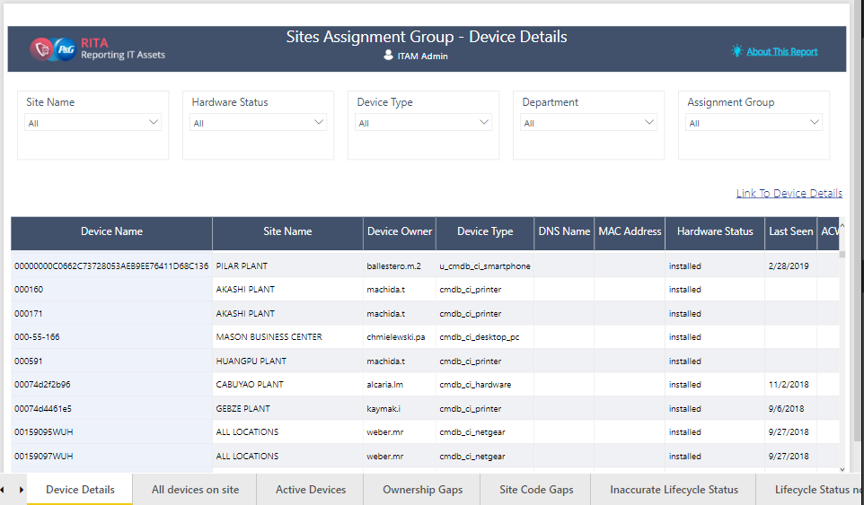

**All Device on Site (For All Groups)**

1. List of Attributes Used

Device Name

Site Name

Device Owner

Device Type

DNS Name

MAC Address

Hardware Status

Last Seen

ACWL Status

Assignment Group

Discovery Source

Is EPO Managed?

Standard Patch Not Installed

SNOW ID

PG Asset ID

EVP Enrolment Status

1. Page level Filter

Assignment group is not Blank.

Is ITAM Assignment is True  
Is register is 1

Life Cycle Status is not in (Decommissioned, Duplicate_invalid)

Hardware Status is not duplicate_invalid or decommissioned

1. Report Level Filter

Site, Hardware Status, Device Type, Department, Assignment Group

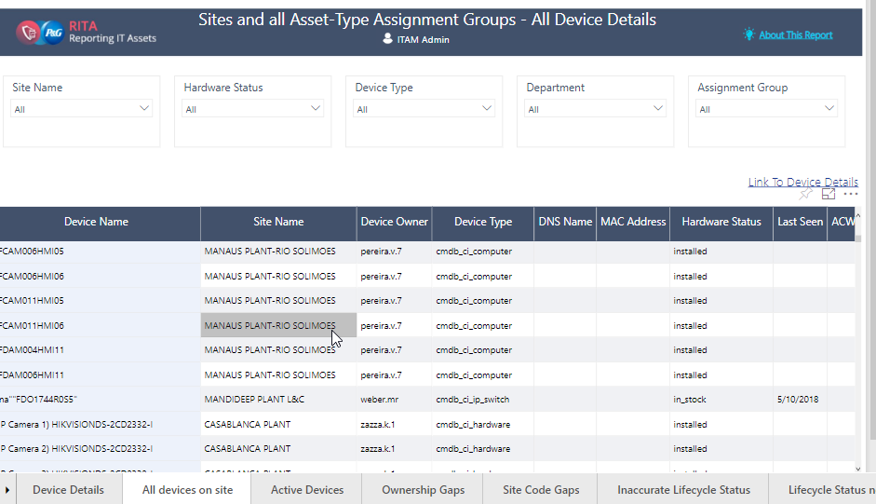

**Active Devices (For All Groups)**

1. List of Attributes Used

Device Name

Site Name

Device Owner

Device Type

DNS Name

MAC Address

Hardware Status

Last Seen

ACWL Status

Assignment Group

Discovery Source

Is EPO Managed?

Standard Patch Not Installed

SNOW ID

PG Asset ID

EVP Enrolment Status

1. Page Level Filter

Assignment group is not Blank.

Is ITAM Assignment is True  
Is register is 1

Life Cycle Status is not in (Decommissioned, Duplicate_invalid)

Hardware Status is not duplicate_invalid or decommissioned

1. Report Level Filter

Site, Hardware Status, Device Type, Department, Assignment Group, Country, Region, Area 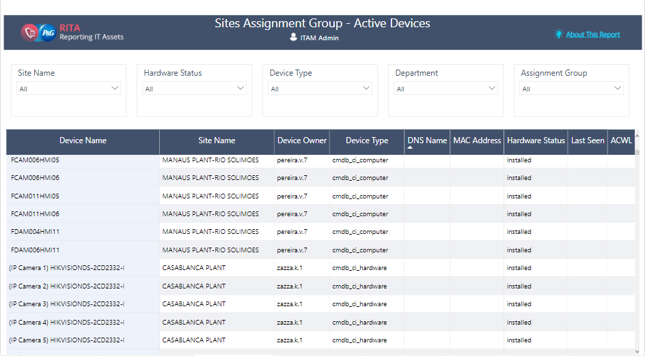

**Ownership Gap (For All Groups)**

1. List of Attributes Used

Device Name

Device Type

Assignment Group

Discovery Source

Device Owner

Employee Type

Site Name

HR Status ID

Hardware Status

Last Seen

SNOW ID

PG Asset ID

1. Page Level Filters

Assignment Group is not blank

Is Register is 1

Life Cycle Status is not in (Decommissioned, Duplicate_invalid)

1. Report Level Filter

Site, Hardware Status, Device Type, Department, Assignment Group, Country, Region, Area

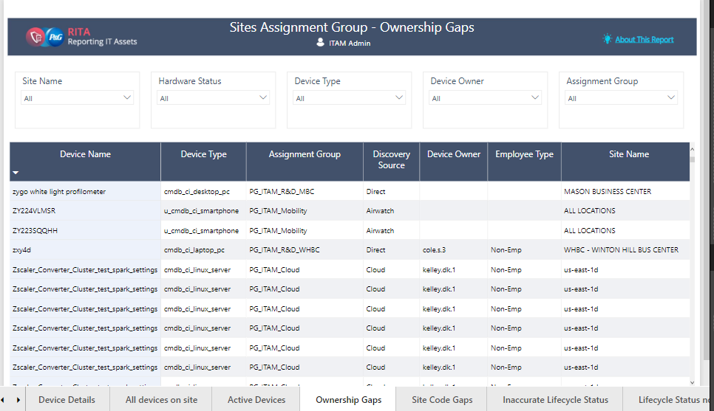

**Site Code Gaps (For All Groups)**

1. List of Attributes

Device Name

Device Owner

Assignment Group

Discovery Source

Site Name

Site Code

Site Type

Status

Device type

Hardware Status

Last Seen

SNOW ID

PG Asset ID

Serial Number

1. Page Level Filter

Assignment Group is not blank.

Is Registered is 1

Life Cycle Status is not in (Decommissioned, Duplicate_invalid)

1. Report Level Filter

Site, Hardware Status, Device Type, Department, Assignment Group, Country, Region, Area

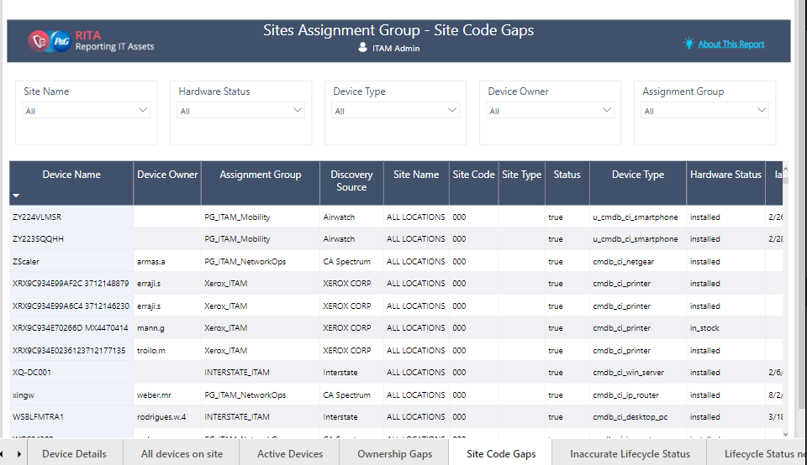

**Inaccurate Lifecycle Status (For All Groups)**

1. List of Attributes

Device Name

Device Owner

Device Type

Assignment Group

Discovery Source

Site Name

Site Code

Hardware Status

Last Seen

SNOW ID

PG Asset ID

Serial Number

1. Page Level Filter

Assignment Group is not blank.

Is Registered is 1

Network connected is not NO

Life Cycle Status is not in (Decommissioned, Duplicate_invalid)

1. Report Level Filter

Site, Hardware Status, Device Type, Department, Assignment Group, Country, Region, Area

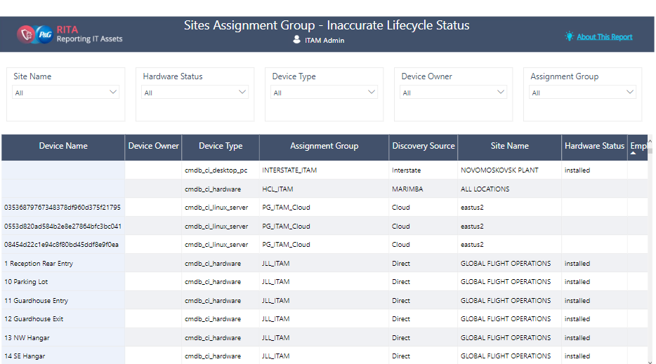

**Life Cycle Status is not Available ( For All Groups)**

1. List of Attributes

Device Name

Device Owner

Site Name

Site Code

Device Type

Last seen

Assignment Group

Hardware Status

Snow ID

PG Asset ID

Serial Number

1. Page Level Filter

Assignment Group is not blank.

Is Registered is 1

Life Cycle Status is not in (Decommissioned, Duplicate_invalid)

1. Report Level Filter

Site, Hardware Status, Device Type, Department, Assignment Group, Country, Region, Area

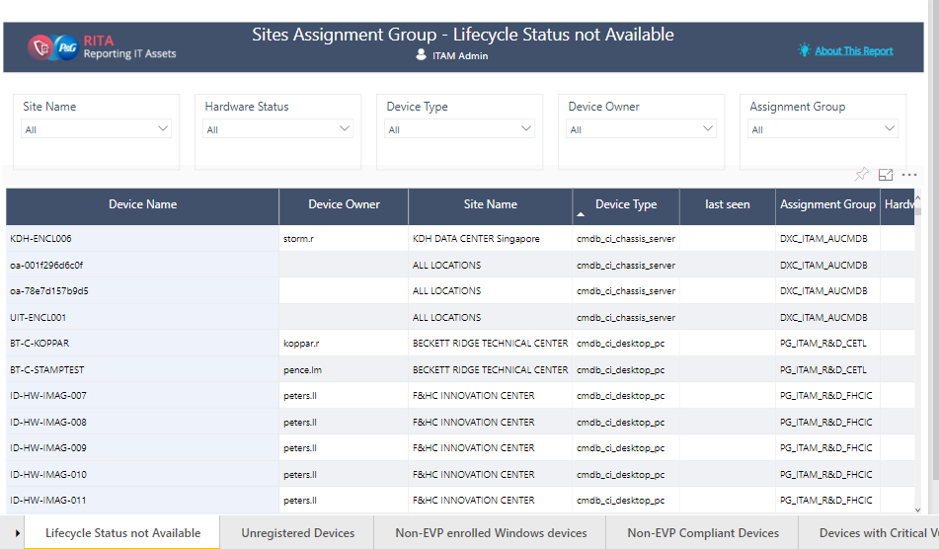

**Unregistered Device (For All Groups)**

1. List of Attributes

DNS Name

SITE Name

Site Code

IP Address

OS Description

IPAM Description

MAC Address

Last Seen

Tenable Discovery ID

Updated Date

1. Page Level Filter

Is Registered is 0

Lifecycle Status is not duplicate_invalid or decommissioned

Last Seen < 90 days

DNS name or MAC address available

1. Report Level Filter

Site, Country, Region, Area

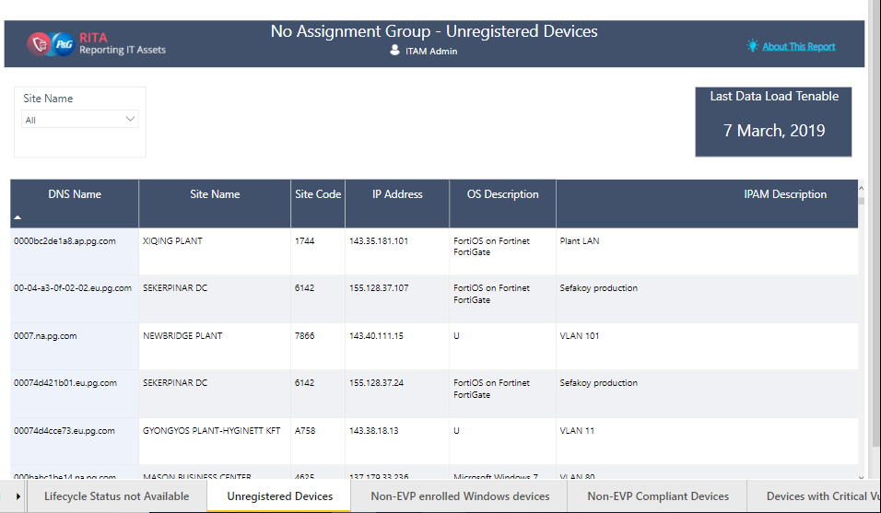

**Unregistered Device Disposal Watchlist (For All Groups)**

1. List of Attributes

DNS Name

SITE Name

Site Code

IP Address

OS Description

MAC Address

Last Scan Date

Tenable Discovery ID

1. Page Level Filter

Is Registered is 0

Lifecycle Status is not duplicate_invalid or decommissioned

Last Seen > 90 days

DNS name or MAC address available

1. Report Level Filter

Site, Country, Region, Area



**Managed Device (For All Groups)**

1. List of Attributes

Device Name

Site Name

Site Code

Device Owner

Discovery Source

Device Type

Hardware Status

OS Description

SNOW ID

PG Asset ID

EPTM Full Scan Date

Assignment Group

1. Page Level Filter

Devices falling into the following classes which cannot be found in the following Discovery Sources:

Classes:

- Windows Server

- Computer

- Laptop PC

- Desktop PC

- Smartphone

- Tablet

Discovery Source:

- AUCMDB

- Interstates

- MARIMBA

- Airwatch

Assignment Group is not (Blank)

Network connected is not NO

Hardware Status is Installed

1. Report Level Filter

Site, Hardware Status, Device Type, Device Owner, Discovery Source

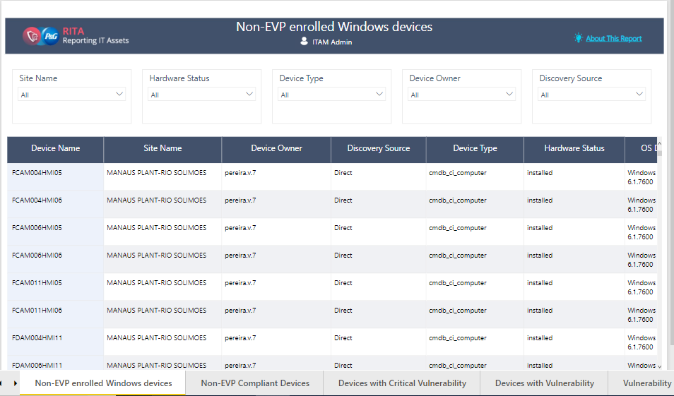

**Offline Devices With Obsolete OS (For All Groups)**

1. List of Attribute

Device Name

SNOW ID

PG asset ID

Assignment Group

Device Owner

OS Service Pack

Site Name

Discovery Source

OS Information

Hardware Status

Device Type

Last Seen

Anti Virus Information

1. Page level Filter

Assignment Group Type is not Blank

Is Accountable is True

Is Registered is 1

Network Connected is No

Obsolete Flag is True

1. Report Level Filter

Life Cycle Status is not in (Decommissioned, Duplicate_invalid)

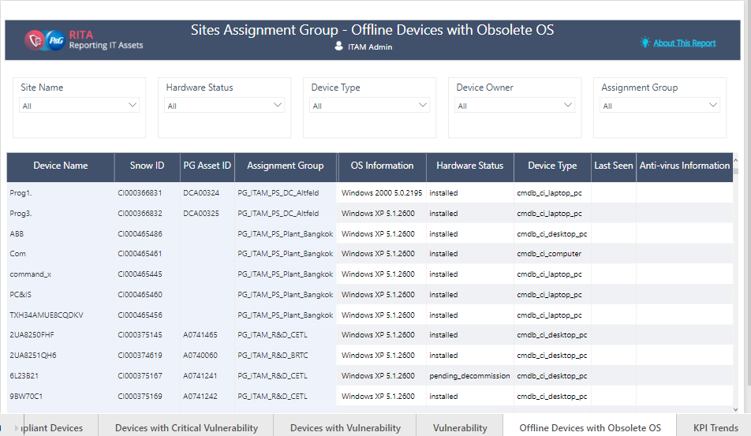

**KPI Trend (For All Groups)**

1. Trendline Charts for

#/%Unregistered Devices, %Registered Devices, % site accuracy, % ownership accuracy, % Lifecycle status accuracy, # managed devices, % Managed, #Active Devices

1. Report Level Filter

Site, Assignment Group, Country, Region, Area, Lifecycle status